**DOCKER**

**DOCKER COMMANDS**

docker –version : To see the docker version

Docker: To view the list of docker commands

docker images: Displays the list of images

docker pull hello-world: To pull image

docker run -p 8000:80 hello-world:To run the image

docker ps: To get the ID of container

docker stop feb5d9fea6a5: To stop container

docker ps –a: To show stopped container and existing container

docker rm bc3fa9b9a2f0:To remove the stopped container

**CREATING A MULTICONTAINER APP WITH DOCKER COMPOSE**

**Webapi**

**program.cs**

using Microsoft.Extensions.Caching.Distributed;

using Microsoft.Extensions.Caching.StackExchangeRedis;

var builder = WebApplication.CreateBuilder(args);

// Add services to the container.

builder.Services.AddControllers();

// Learn more about configuring Swagger/OpenAPI at https://aka.ms/aspnetcore/swashbuckle

builder.Services.AddEndpointsApiExplorer();

builder.Services.AddSwaggerGen();

builder.Services.AddStackExchangeRedisCache(options =>

{

options.Configuration = "redis:6379"; // redis is the container name of the redis service. 6379 is the default port

options.InstanceName = "SampleInstance";

});

var app = builder.Build();

// Configure the HTTP request pipeline.

if (app.Environment.IsDevelopment())

{

app.UseSwagger();

app.UseSwaggerUI();

}

app.UseHttpsRedirection();

app.UseAuthorization();

app.MapControllers();

app.Run();

**CounterController.cs**

using Microsoft.AspNetCore.Mvc;

using Microsoft.Extensions.Caching.Distributed;

using StackExchange.Redis;

namespace WebApi.Controllers

{

[ApiController]

[Route("[controller]")]

public class CounterController : ControllerBase

{

private readonly ILogger<CounterController> _logger;

private readonly IDistributedCache _cache;

public CounterController(ILogger<CounterController> logger, IDistributedCache cache)

{

_logger = logger;

_cache = cache;

}

[HttpGet(Name = "GetCounter")]

public string Get()

{

string key = "Counter";

string? result = null;

try

{

var counterStr = _cache.GetString(key);

if (int.TryParse(counterStr, out int counter))

{

counter++;

}

else

{

counter = 0;

}

result = counter.ToString();

_cache.SetString(key, result);

}

catch (RedisConnectionException)

{

result = $"Redis cache is not found.";

}

return result;

}

}

}

**Webapp**

**Index.cshtml.cs**

using Microsoft.AspNetCore.Mvc;

using Microsoft.AspNetCore.Mvc.RazorPages;

namespace dockercompose.Pages

{

public class IndexModel : PageModel

{

private readonly ILogger<IndexModel> _logger;

public IndexModel(ILogger<IndexModel> logger)

{

_logger = logger;

}

public async Task OnGet()

{

using (var client = new System.Net.Http.HttpClient())

{

// Call *mywebapi*, and display its response in the page

var request = new System.Net.Http.HttpRequestMessage();

// webapi is the container name

request.RequestUri = new Uri("http://webapi/Counter");

var response = await client.SendAsync(request);

string counter = await response.Content.ReadAsStringAsync();

ViewData["Message"] = $"Counter value from cache :{counter}";

}

}

}

}

**Index.cshtml**

@page

@model IndexModel

@{

ViewData["Title"] = "Home page";

}

<div class="text-center">

<h1 class="display-4">Welcome</h1>

<p>Learn about <a href="https://docs.microsoft.com/aspnet/core">building Web apps with ASP.NET Core</a>.</p>

<p>@ViewData["Message"]</p>

</div>

**Dockercompose**

**Docker-compose.yml**

version: '3.4'

services:

dockercompose:

image: ${DOCKER_REGISTRY-}dockercompose

build:

context: .

dockerfile: dockercompose/Dockerfile

webapi:

image: ${DOCKER_REGISTRY-}webapi

build:

context: .

dockerfile: webapi/Dockerfile

redis:

image: redis

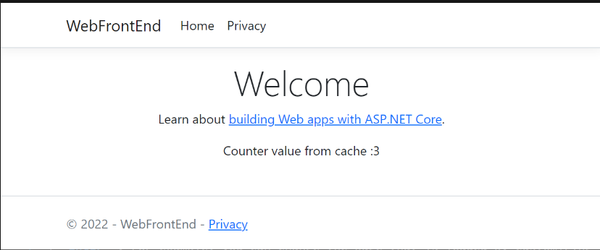

**CI/CD PIPELINE FOR DOCKER**

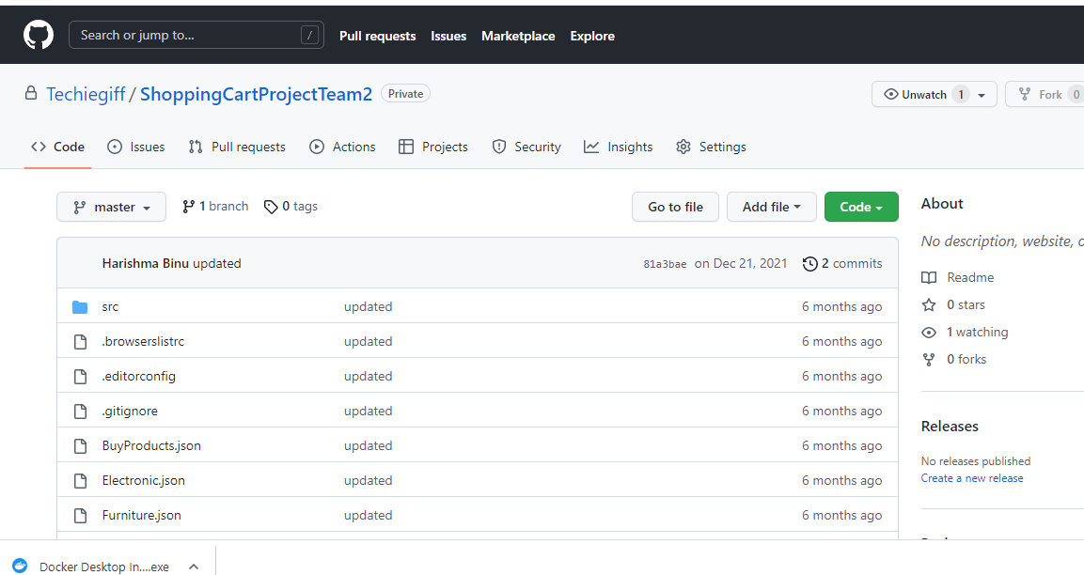

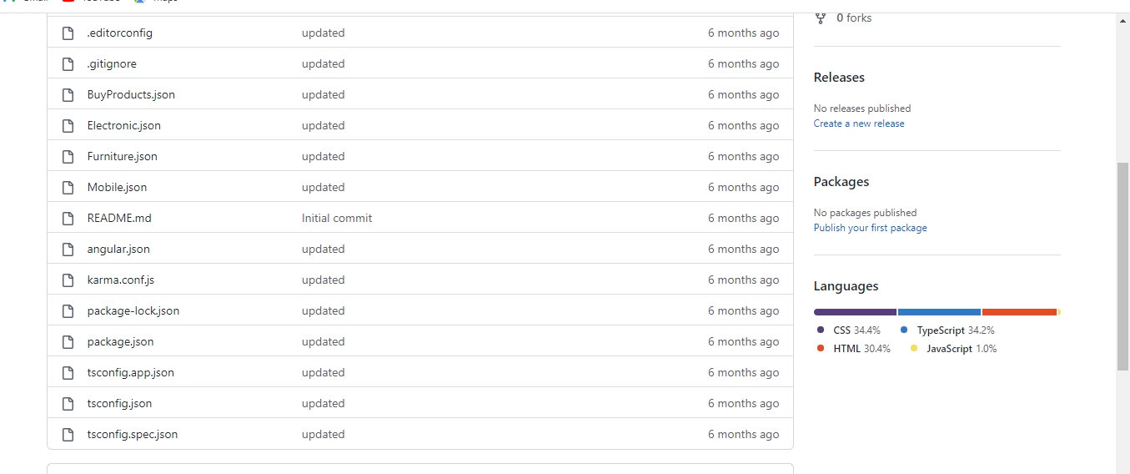

**Register.yml**

|  |  |
| --- | --- |
|  |  |
|  | name: CI |
|  |  |
|  | # Controls when the workflow will run |
|  | on: |
|  | # Triggers the workflow on push or pull request events but only for the "master" branch |
|  | push: |
|  | branches: [ "master" ] |
|  | pull_request: |
|  | branches: [ "master" ] |
|  |  |
|  | # Allows you to run this workflow manually from the Actions tab |
|  | workflow_dispatch: |
|  |  |
|  | # A workflow run is made up of one or more jobs that can run sequentially or in parallel |
|  | jobs: |
|  | # This workflow contains a single job called "build" |
|  | build: |
|  | # The type of runner that the job will run on |
|  | runs-on: ubuntu-latest |
|  |  |
|  | # Steps represent a sequence of tasks that will be executed as part of the job |
|  | steps: |
|  | # Checks-out your repository under $GITHUB_WORKSPACE, so your job can access it |
|  | - uses: actions/checkout@v3 |
|  |  |
|  | # Runs a single command using the runners shell |
|  | - name: Run a one-line script |
|  | run: echo Hello, world! |
|  |  |
|  | # Runs a set of commands using the runners shell |
|  | - name: Run a multi-line script |
|  | run: | |
|  | echo Add other actions to build, |
|  | echo test, and deploy your project. |

